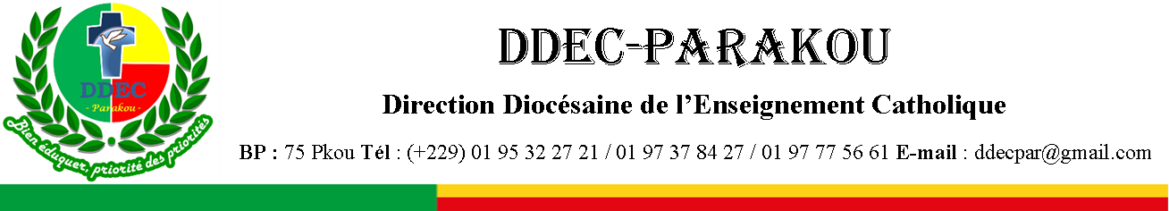

EXAMEN BLANC DU BACCALAUREAT : SESSION DE FEVRIER 2026 EPREUVE : ANGLAIS (LV2)
SERIES : A₁ - A₂ DUREE : 02h COEF : 02

NB : Prière écrire LV 2 sur la feuille de composition
Compétences à évaluer :
CD2 : La Réaction à un texte ou un support multi-média lu ou entendu
CD3 : La Production d’un texte de type particulier ou de fonctions variées L’Epreuve
A- LA REACTION A UN TEXTE OU UN SUPPORT MULTI-MEDIA LU OU ENTENDU.
Contexte : L’expansion de la langue anglaise dans plusieurs domaines n’est plus à démontrer. Cette langue est même devenue incontournable dans bon nombre de domaines aujourd’hui.
Support : Le texte ci-dessous.
Text : ENGLISH IN TRADE, SCIENCE AND SCHOLARSHIP
English has been expanding largely because of the emergence of the US and the British Commonwealth as the dominant players in world trade. In this game, it is the buyer’s language, not the seller’s that comes out on top – especially when the buyer is truly king.
The economic and military power of the US and its role in saving Europe from two world wars has promoted English to the status of the foremost diplomatic language, thus demoting French. Its prestige, along with the United Kingdom’s, in science and technology has also made English the dominant world lingua franca of scholarship. Even the French and the Germans, economically powerful and influential as they are in science and technology, have had to bow to English. More and more of their scholars publish in English.
To be sure, there are languages such as Hindi and Mandarin, and in fact even Spanish, which have more mother‑tongue speakers than English. But from the point of view of what language one needs to be competitive in the scholarly and business world today, English dominates.
In fact, the rise of China as a leading world economic power is helping the spread of English more than it does Mandarin. Since the 1950s, even more countries have adopted English as their international language of trade and scholarship. The Indian‑born linguist Braj Kachru at the University of Illinois at Urbana‑Champaign refers to them as the “Expanding Circle.” This is in opposition to the “Inner Circle” and the “Outer Circle.” The Inner Circle includes all countries where English is the mother tongue of the majority population. By contrast, the “Outer Circle” consists of Britain’s former colonies, in which English is an official language but is not spoken as a mother tongue by the overwhelming majority of its users.
By Salikoko S. Mufwene. Extracted from The New English Student Tle

by Dr LANMACHION, P. 132
Critères d’évaluation: Après avoir lu le texte, tu montreras que tu l’as compris en :
- Choisissant la meilleure portion pour compléter les idées tirées du texte,
- répondant de façon précise à des questions sur le texte,
- montrant ta maitrise de son vocabulaire,
- reformulant certaines de ses phrases de façon autonome et en
- traduisant une de ses portions en français.
Tâche/consignes
Item 1: Choose the best ending for each of the following sentences. Don’t copy the sentences
but use numbers and letters only.
- English became the foremost diplomatic language because ……………..…
  - it has more native speakers than French
  - of the US’s economic and military power after two world wars
  - it is easier to learn than French
  - Britain colonized more countries
- The role the United Kingdom played in the spread of English was…………..
  - Its prestige in science and technology
  - Its dominance in agriculture
  - Its cultural influence through cinema
  - Its population size
- The concept of the “Expanding Circle” was introduced by …………...
  - Salikoko S. Mufwene
  - Noam Chomsky
  - Braj Kachru
  - Ferdinand de Saussure
- The country whose rise as an economic power has ironically helped spread English more than Mandarin is ……….……
  - India
  - Germany
  - China
  - France
Item 2: Answer the following questions based on the text.
    - Why does the text say “the buyer’s language comes out on top” ?
    - How did the US contribute to the promotion of English in diplomacy ?
    - What is the difference between the “Inner Circle” and the “Outer Circle” ?
Item 3: Find from the text words or groups of words having the same or almost the same meanings as the following.
- Leading (Paragraphe1)
- Submit to (Paragraphe 2)
- Market-driven (Paragraphe 3)
- In contrast with (Paragraphe 4)
Item 4: Rewrite the following sentences using the given prompts. Don’t change their meaning.

- “English dominates the scholarly and business world today,” said Mufwene.
  - Mufwene said………………………………………………..
- The US promoted English to the status of foremost diplomatic language.
  - English was………………………………………………………………..
- Hindi and Mandarin have more native speakers, but English dominates globally.
  - Although Hindi ………………………………………………………….
- Countries may adopt English for international trade. They may adopt Mandarin as well.
  - Countries may adopt either ……………………………………………
Item 5: Translate the following passage into French.
“Since the 1950s, more and more countries have adopted English as their international language of trade and scholarship. This expansion has reinforced English as the dominant lingua franca in the modern world.”
B- LA PRODUCTION D’UN TEXTE DE TYPE PARTICULIER OU DE FONCTIONS VARIEES
Contexte : L’anglais a certainement un rôle à jouer dans la vie d’un élève.
Critères d’évaluation: Tu montreras ta compétence à écrire un article en anglais en :
- respectant le contexte et le type de texte
- la logique interne du texte,
- faisant des phrases significatives et grammaticalement correctes et en
- utilisant le vocabulaire, l’orthographe et la ponctuation appropriés.
Tâche/consigne
Writing : Write a paragraph to say how important the English language is for you as a student.

