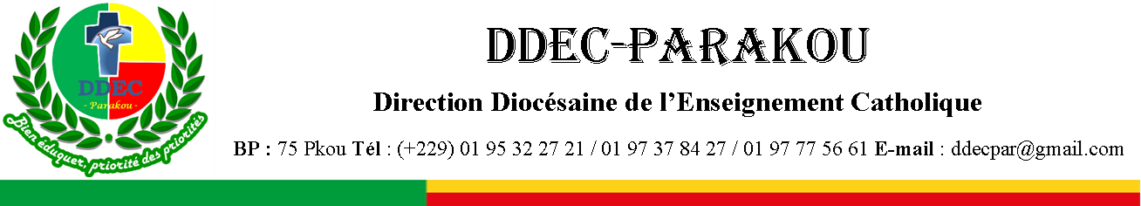
EXAMEN BLANC DU BACCALAUREAT : SESSION DE FEVRIER 2026 EPREUVE : ANGLAIS
SERIES : C&D DUREE : 03heures COEF : 02

Compétences à évaluer :
CD2 : La Réaction à un texte ou un support multi-média lu ou entendu
CD3 : La Production d’un texte de type particulier ou de fonctions variées
L’Epreuve
A- LA REACTION A UN TEXTE OU UN SUPPORT MULTI-MEDIA LU OU ENTENDU.
Contexte : Comprendre que le monde constitue une seule famille est bénéfique pour tous les peuples.
Support : Le texte ci-dessous
Text :
The phrase “The world is a family” comes from an old idea in many cultures that all human beings are connected. Even though people live in different countries, speak different languages, and follow different traditions, we share the same Earth. Just like members of a family care for one another, people across the world must learn to respect and support each other. When one country faces problems like natural disasters, wars, or disease, others can help by sending aid, sharing knowledge, or offering friendship. This idea teaches us that kindness and cooperation should not stop at borders. A healthy lifestyle for the world means living with peace, respect, and care for everyone. It also reminds us that no matter how far apart we live, our actions affect others. Pollution in one place can spread across oceans, and kindness in one place can inspire people everywhere. Thinking of the world as one family helps us understand that we are stronger together than apart.
We can see examples of this family spirit in everyday life. International organizations like UNICEF or WHO help children and families in need across the globe. Scientists share discoveries so that medicines and vaccines can reach people everywhere. Students in different countries can connect through books, the internet, and cultural exchanges, learning that they are more alike than different. Even small actions—like recycling to protect the environment, donating clothes, or writing letters of peace—show that we care for our global family. Just as brothers and sisters share responsibilities at home, nations and individuals must share responsibility for keeping the Earth safe and healthy. When countries work together to fight climate change, protect forests, and reduce pollution, they are acting like members of one family. Children can also practice this idea by being kind to classmates, helping friends, and respecting differences. These small steps build habits of cooperation that grow into global peace.
When we accept that the world is a family, we understand that hurting others also hurts us. Violence in one region can cause fear and sadness across the globe, while peace and cooperation

bring hope everywhere. Families are stronger when their members trust and support each other, and the same is true for the world. By practicing kindness, sharing resources, and caring for nature, we can build a future where everyone feels safe, valued, and loved. Children who learn this lesson early will grow into adults who respect diversity and protect the planet. A healthy lifestyle for the world means choosing peace instead of conflict, fairness instead of selfishness, and care instead of neglect. The idea of one family teaches us that we are responsible for each other’s happiness. When we care for ourselves and others, we create a world where everyone can live with dignity, joy, and hope.
Source: Adapted from UNICEF – From survival to safety: how UNICEF supports children in emergencies.
Critères d’évaluation: Après avoir lu le texte, tu montreras que tu l’as compris en :
- appréciant certaines déclarations issues du texte,
- complétant des phrases par des informations du texte
- répondant de façon précise à des questions sur le texte,
- identifiant des antonymes de certains mots à partir du texte,
- reformulant certaines phrases du texte de façon autonome et en
- traduisant une de ses portions en français.

Item 1: Say whether each statement is True (T) or False (F) according to the text.
- The text says that kindness should stop at borders.
- UNICEF and WHO are examples of organizations that help globally.
- Recycling and donating clothes are small actions that show care for the world.
- Families are stronger when members fight against each other.

Item 2: Fill in the blanks with words/phrases from the text. Don’t copy the sentences. Just write
numbers and answers only.
- When one country faces problems like , wars, or disease, others can help.
- Pollution in one place can spread across .
- International organizations like or WHO help children and families in need.
- Children who learn this lesson early will grow into adults who respect .

Item 3: Answer in complete sentences the following questions.
- How can countries show family spirit when facing global problems?
- Give two examples of everyday actions that show care for the global family.
- Why does the text say that violence in one region affects the whole world?
- What kind of future can be built if people practice kindness and cooperation?

Item 4: Find antonyms in the text for the following words.
- Together (Paragraph 1)
- Peace (Paragraph 3)
- Care (Paragraph 3)
- Sadness (Paragraph 3)

Item 5: Rewrite the sentences using different words but keeping the same meaning.
- People across the world must learn to respect and support each other.
  - People worldwide should …………………………………………………
- Nations must share responsibility for keeping the Earth safe and healthy.

  - It is a shared duty of nations to ……………………………………………
- Violence in one region can cause fear across the globe.
  - Violence in one region leads ………………………………………………
- A healthy lifestyle for the world means choosing peace instead of conflict.
  - To ensure a healthy world, we should ……………………………………

Item 6: Translate this passage into French:
From "Just as brothers and sisters ……” down to “………like members of one family." (in Paragraph 2)

B- LA PRODUCTION D’UN TEXTE DE TYPE PARTICULIER OU DE FONCTIONS VARIEES
Contexte : Les périodes électorales constituent des moments de tensions et de conflits.
Critères d’évaluation : Tu montreras ta compétence à écrire un essai en anglais en :
- respectant le contexte et le type de texte
- la logique interne du texte,
- faisant des phrases significatives et grammaticalement correctes et en
- utilisant le vocabulaire, l’orthographe et la ponctuation appropriés.

Support: L’image ci-dessous.
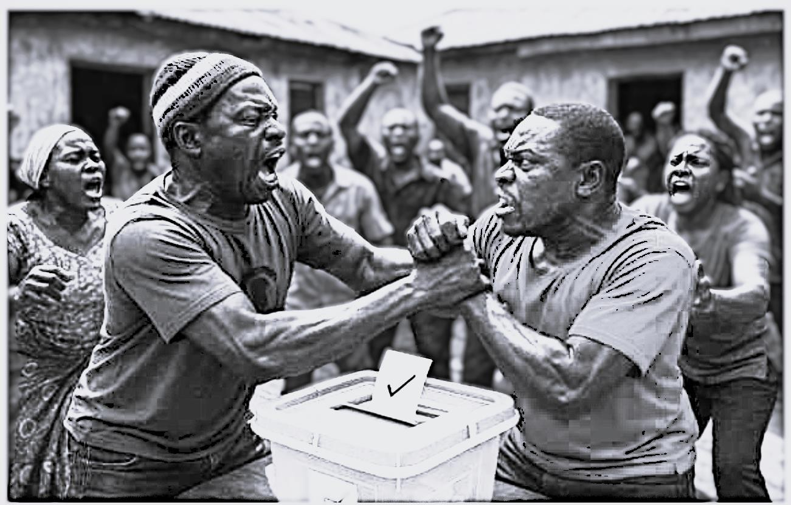

Tâche/consigne
Writing : Basing on the picture above, write an essay entitled “Political tension and democratic struggle”. The following clues can help you:
  - Describe the picture.
  - Say the problems that they raise.
  - Suggest solutions to the problems raised by the picture.

